

Use Case Specification: Supervisor eCL Quality Feed
For

eCoaching Log

Change History Log

Date | Version | Description | Author
07/11/2016 | 1.0 | Initial Document | Doug Stearns

Table of Contents

1. Brief Description 6
2. Participating Actors 6
2.1 Primary 6
2.2 Secondary 6
3. Basic Flow of Events 7
3.1 System process executes at the scheduled time. 7
3.2 Input file accessed from appropriate folder. 7
3.3 eCoaching Log information is read from the input file. 7
3.4 Assign the coaching log Program from the input Employee ID. 7
3.5 Assign 231 for Coach the coach as the value of the coaching log source id. 7
3.6 Assign ‘Pending Acknowledgement’ as the value of the coaching log status. 7
3.7 Assign the coaching log Site ID from the Employee record Site ID. 7
3.8 Assign the coaching log Employee LAN ID from the Employee record LAN ID when a match is found with the input Employee ID. 7
3.9 Assign the coaching log Employee ID from the input Employee ID. 7
3.10 Assign the coaching log Submitter ID from the input Submitter ID. 7
3.11 Assign the coaching log Call Date from the input Event Date. 7
3.12 Assign 0 as the value for whether an Avoke ID is associated with the input record. 7
3.13 Assign 0 as the value for whether a NGD Activity ID is associated with the input record. 7
3.14 Assign 0 as the value for whether an UCID is associated with the input record. 7
3.15 Assign 0 as the value for whether a Verint ID is associated with the input record. 7
3.16 Assign the coaching log Description from the input concatenation of concatenation of text description fields from input file. 7
3.17 Assign the coaching log Submitted Date from the input file. 8
3.18 Assign the coaching log Start Date from the input Event Date. 8
3.19 Assign 0 as the value of whether this coaching log is Acknowledged. 8
3.20 Assign 2 as the value of the coaching log Module ID. 8
3.21 Assign Coaching as the value of the coaching log Reason, Supervisor eCL Coaching as the value of the coaching log sub-reason and Reinforcement as the value for the coaching log. 8
3.22 Assign value of employee’s supervisor. 8
3.23 Assign value of employee’s manager. 8
3.24 Submit the Supervisor Quality Report eCoaching Log 8
4. Alternative Flows 9
4.1 Employee Not Found. [Step 3.8] 9
5. Preconditions 9
5.1 Quality Report eCoaching Log input file exists and is available. 9
5.2 eCoaching Log database available. 9
5.3 eCoaching Log database populated with correct and current hierarchy information for Employee, Supervisors, Managers. 9
6. Postconditions 9
6.1 eCoaching Log submitted. 9
7. Assumptions and Dependencies 9
7.1 Input file is processed every day. 9
8. Business Rules 9
8.1 none 9
9. Technical Requirements 9
9.1 none 9
10. Activity Diagrams 10

Table of Figures
Figure 1 – Supervisor Quality Report eCL Submission 11

Brief Description
Allow eCoaching Logs from Quality Reporting to be submitted through Quality data feed.

Participating Actors

Primary

System process

Employees (Supervisors)

Secondary

Supervisors (Managers)

Basic Flow of Events

System process executes at the scheduled time.

Input file accessed from appropriate folder.

eCoaching Log information is read from the input file.

Assign the coaching log Program from the input Employee ID.

Assign 231 for Coach the coach as the value of the coaching log source id.

Assign ‘Pending Acknowledgement’ as the value of the coaching log status.

Assign the coaching log Site ID from the Employee record Site ID.

Assign the coaching log Employee LAN ID from the Employee record LAN ID when a match is found with the input Employee ID.

Assign the coaching log Employee ID from the input Employee ID.

Assign the coaching log Submitter ID from the input Submitter ID.

Assign the coaching log Call Date from the input Event Date.

Assign 0 as the value for whether an Avoke ID is associated with the input record.

Assign 0 as the value for whether a NGD Activity ID is associated with the input record.

Assign 0 as the value for whether an UCID is associated with the input record.

Assign 0 as the value for whether a Verint ID is associated with the input record.

Assign the coaching log Description from the input concatenation of concatenation of text description fields from input file.

The following characters from the input record will be replaced with the corresponding string of characters:
& | &amp;
< | &lt;
> | &gt;
` | &#39;
" | &quot;
‘ | &lsquo;
’ | &rsquo;
’ | &prime;
? | &Prime;
“ | &ldquo;
” | &rdquo;
- | &ndash;

Assign the coaching log Submitted Date from the input file.

Assign the coaching log Start Date from the input Event Date.

Assign 0 as the value of whether this coaching log is Acknowledged.

Assign 2 as the value of the coaching log Module ID.

Assign Coaching as the value of the coaching log Reason, Supervisor eCL Coaching as the value of the coaching log sub-reason and Reinforcement as the value for the coaching log.

Assign value of employee’s supervisor.

Assign value of employee’s manager.

Submit the Supervisor Quality Report eCoaching Log

Alternative Flows

Employee Not Found. [Step 3.8]

When input Employee ID match is not found in the Employee records reject the input record.

Continue with Step 3.9 above.

Preconditions

Quality Report eCoaching Log input file exists and is available.

eCoaching Log database available.

eCoaching Log database populated with correct and current hierarchy information for Employee, Supervisors, Managers.

Postconditions

eCoaching Log submitted.

Assumptions and Dependencies

Input file is processed every day.

Business Rules

none

Technical Requirements

none

Activity Diagrams
Below is the activity diagram for the use case that provides a visual depiction of the flow of events.

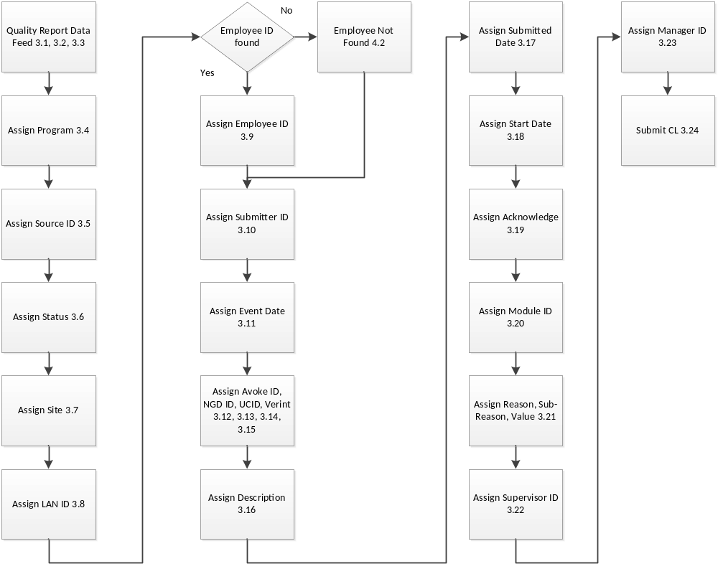

Figure 1 – Supervisor Quality Report eCL Submission

